Weekly Guide

W/C Monday 2nd September 2024 Letter Sound Aa
What happened over the summer – recap on holidays etc.
Settling in – exploring the setting – the routine
Learning new names and making friends
Focus – PSED – Saying and singing different songs and rhymes to help the children begin to learn the other children’s names
Introduction to the Colour Monsters
Craft – Free Painting
Letters and Sounds Aspect 4 Rhythm and Rhyme
Golden Rule - Kind Words

W/C Monday 9th September 2024 Letter Sound Bb
Who am I? What do I look like?
Our Golden Rules – Feelings (our colour Monsters)
Putting your hand up, do not shout out
My Family Picture Wall display
Focus – Naming body parts, describing ourselves, looking at and noticing the differences between us all –
Mathematics – Pairs (2) – Fingers and Toes counting 0-5
Matching and making sets using hair and eye colour
(Sticky kids head, shoulders and one finger one thumb etc.)
Craft – Plate Faces (looking at hair and eye colours and positioning) Cutting and Sticking – paper ripping to make their faces for room display
Letters and Sounds - Aspect 3 General Sounds & body percussion
Various action songs – Head shoulders knees and toes.
Begin Wiggle and Squiggle (pre writing Activity)
Golden Rule – Kind Hands

Weekly Guide
W/C Monday 16th September 2024 Letter Sound Cc
When we were babies – What we can do now.
Bathing Baby
Growing – How we have changed (then and now) ‘I can’
It is ok to ask for help – Helping others
Focus – Mathematics –Sizing and Measuring (big, bigger and biggest, small smaller and smallest) using mathematical language (height chart – recording)
Craft –Mixing up using different textures (describing how it looks and feels)
Making bottle shakers using a selection of different dried materials.
Letters and Sounds - Aspect 2
Banging on different things (not instruments) to hear the sounds they make
(Plastic bottles, metal pots etc.) Which instrument – match the sounds?
Krazy Kangas – Monday 2.30pm
Golden Rule – Good Sharing

W/C Monday 23rd September 2024 Letter Sound Dd
My Family – brothers, sisters and relations
Other Families
Special Occasions or Events – Birthdays (how old?) Linking to relevant stories
Family Story Time (Children’s family members to come in to read)
Focus – People and Communities – Family/Home - using people characters to talk about children’s families and immediate family relations. Use role-play to talk about significant family events. Revisit the Family Display wall
Craft – Children’s hand prints for Friends Tree
Letters and Sounds Aspect 6 – Voice Sounds
Wiggle and Squiggle
Golden Rule – Walk Inside

Weekly Guide
W/C Monday 30th September 2024 Letter Sound Ee
Where I Live – What we see in our local environment – Play Parks, Local Shops and Kids About – Talking about address (recognising door numbers)
Reinforce Golden Rules from previous week
Keeping Safe – talk about Stranger Danger
Focus – PSED Staying Safe (Getting Lost and Stranger Danger along with Internet Safety)
Pantosaurus – NSPCC Safety Tool
Craft –Shape Houses with Door Numbers/painting shapes
Letters and Sounds – Aspect 1 - Environment Sounds - Listening Walks – Describe it and find it - Sounds from CD’s using Picture Cards
Dough Disco
Golden Rule – Stop Means Stop

W/C Monday 7th October 2024 Letter Sound Ff
Healthy Me! – Hand Washing
My Senses – Sight, Smell, Taste and Touch - Likes and Dislikes
Eating Healthy Foods – Change for life
All about the Dentist (resources on loan from a surgery TBC)
Times of day (morning/afternoon – today and yesterday)
Focus PSED- PD – Tasting, Smelling and Recording
Craft – Vegetable/Fruit Printing – Giant Fruit Bowl
Letters and Sounds – Aspect – 6 Voice Sounds
Krazy Kangas – Wednesday 2.30pm
Golden Rule - Hands up and Wait

Weekly Guide

W/C Monday 14th 23rd October 2024 Letter Sound Gg
Fire Safety Days – Activities, resources, stories and songs about staying safe. This will include safety in the home and outside
Recapping on Stranger Danger and internet safety.
Focus – Staying Safe with regard to Fire and Water
Fire Fighters/Engine Visit (I will let you know what date, when booked☺)
Craft – Recycling Models
Letters and Sounds Aspect 3 – Listen to the music Pg 20
Use Familiar Rhymes to sing fast and slow, loud and soft
Perform an action when the children hear different instrument sounds
(Use 3 different sounds for clap, jump and wave) can extend and change when needed).
Dough Disco
Golden Rule – Re-cap (match an action to a rule)
Wednesday 16th Photographer 4:00 – 6:30
Thursday 17th Fancy Dress Disco £2
Lists will go up nearer the time

HALF TERM
BACK ON MONDAY 4th November

Autumn & Winter
Weekly Guide
October – December 2024

W/C Monday 4th November 2024 Letter Sound Hh
Fire Safety Days Contd – Activities, resources, stories and songs about staying safe. This will include safety in the home and outside – recapping on Stranger Danger and internet safety.
Focus – Staying Safe with regard to Fire and Water
Talking about Fireworks – colours and sounds – Children’s experiences
Firework Song
Diwali – The Rama and Sita Story (31st Oct to Nov 1st)
Craft –Bonfire/Firework Pictures and Rockets
Letters and Sounds Aspect 1
Environment Sounds – Listening to Different types of Music
Wiggle and Squiggle

W/C Monday 11th November 2023 Letter Sound Ii
Leaf Collecting - Signs and smells of autumn

Winter Weather - Frost and Cobwebs (Cold/Frosty/Snow!) –
Children in Need – Friday 15th November
Focus - Showing an interest in the world comment and ask questions as we explore the school and the woodland walk – looking at books
Commenting and asking questions about what they see.
Craft – Cobweb Pictures – Gluey Drizzle Pictures
Plate Hedgehogs - Autumn Trees (hands)
Letters and Sounds Aspect 2 – General Sounds - Wiggle and Squiggle

Autumn & Winter
Weekly Guide
November – December 2024

W/C Monday 18th November 2024 Letter Sound Jj
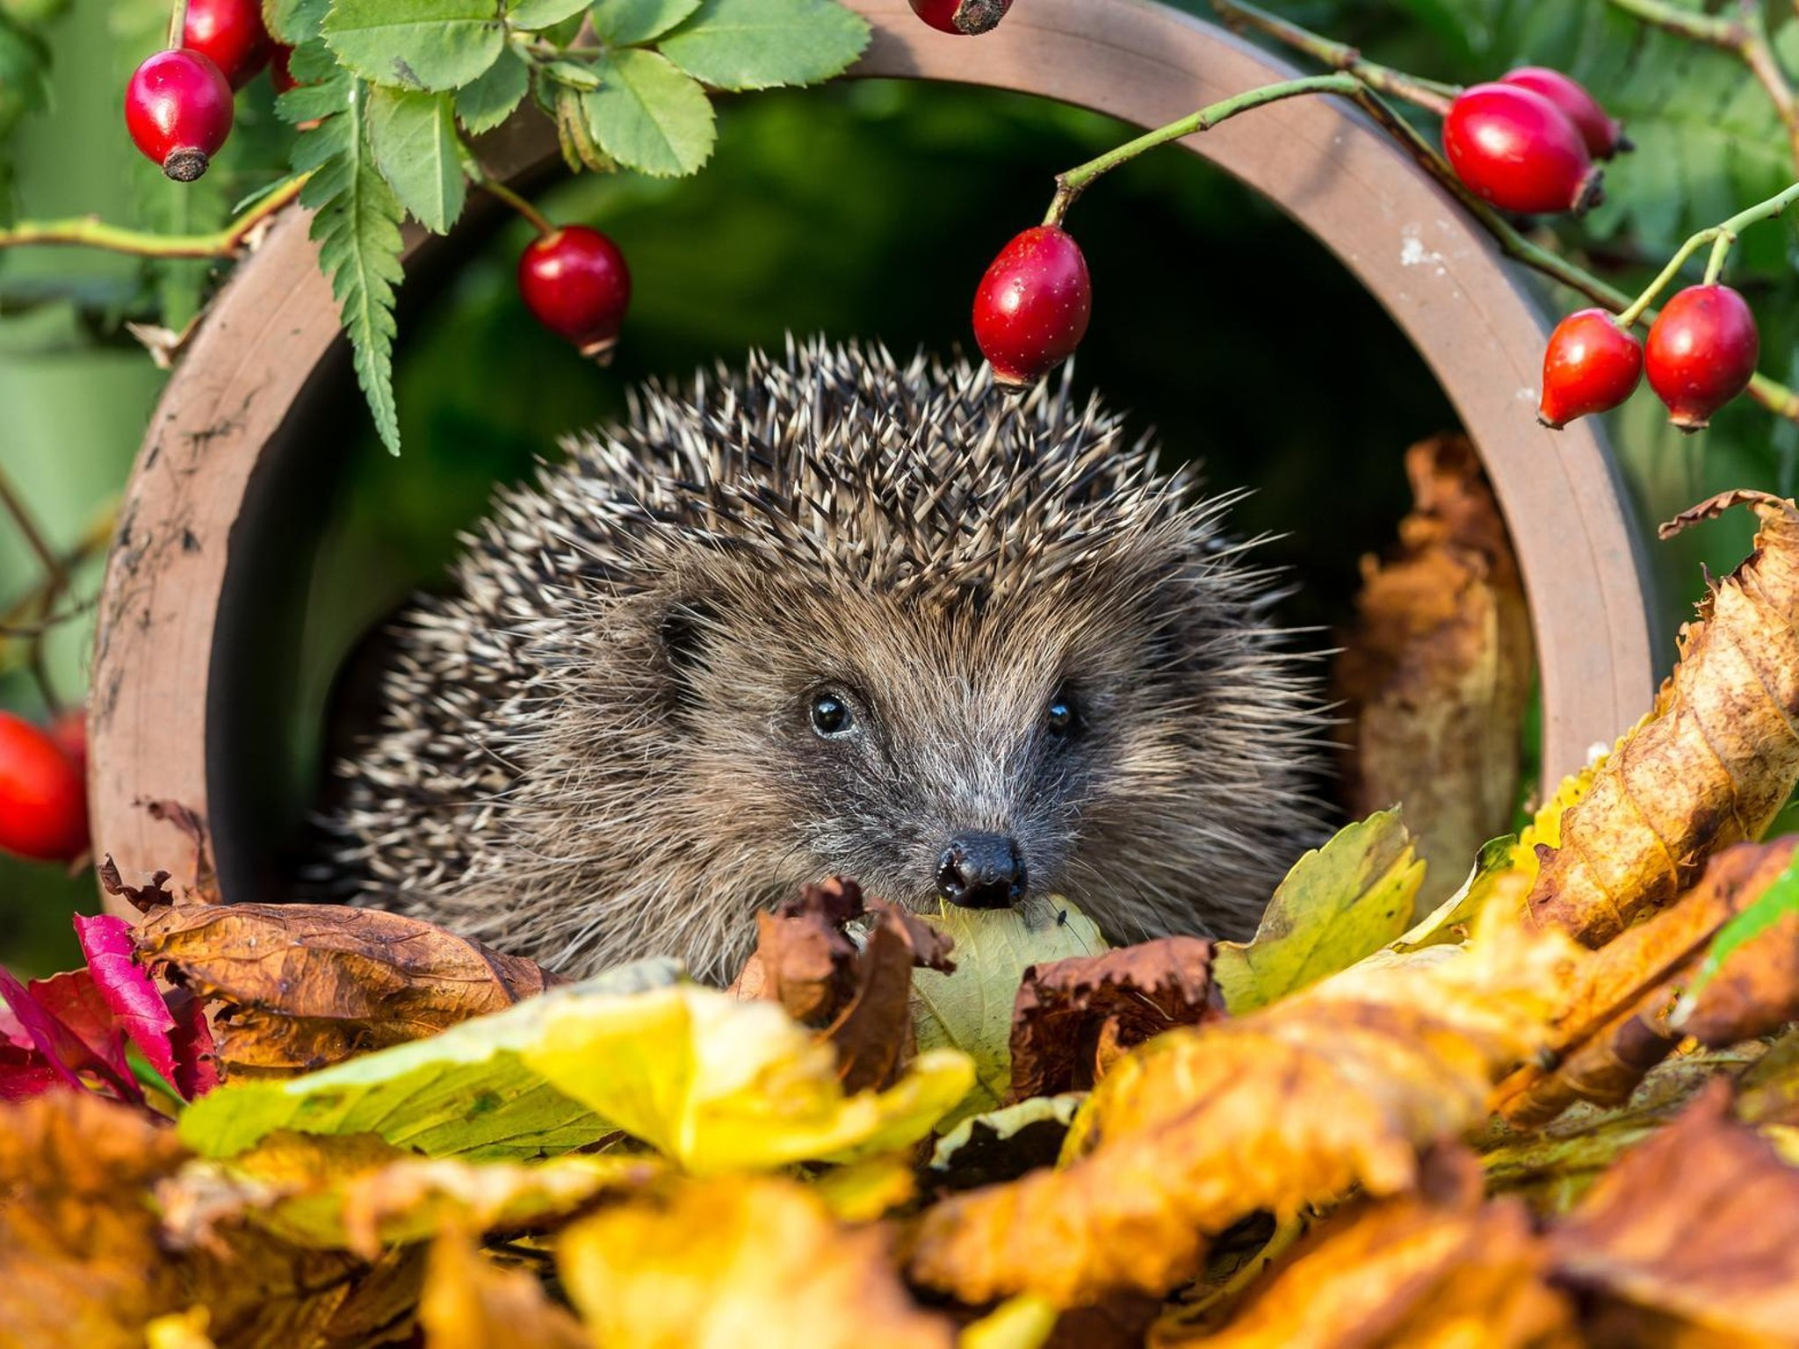
Hedgehogs - Finding out all about them.
Checking our Hedgehog house into the woodland walk
Kindness and caring for others – How we feel
Caring for animals – Food for the birds
Craft – Cobweb Pictures – Gluey Drizzle Pictures
Plate Hedgehogs - Autumn Trees (hands)
Leafman/Stickman pictures
Letters and Sounds Aspect 1 – General and Environment Sounds
Krazy Kangas – Thursday 10.45am
Singing for the Season

W/C Monday 25th November 2024 Letter Sound Kk
Begin Xmas Crafts
Craft – Continuing with ideas from above.
Letters and Sounds Aspect 1 – General and Environment Sounds
Dough Disco
Singing for the Season

W/C Monday 2nd December 2024 Letter Sound Ll
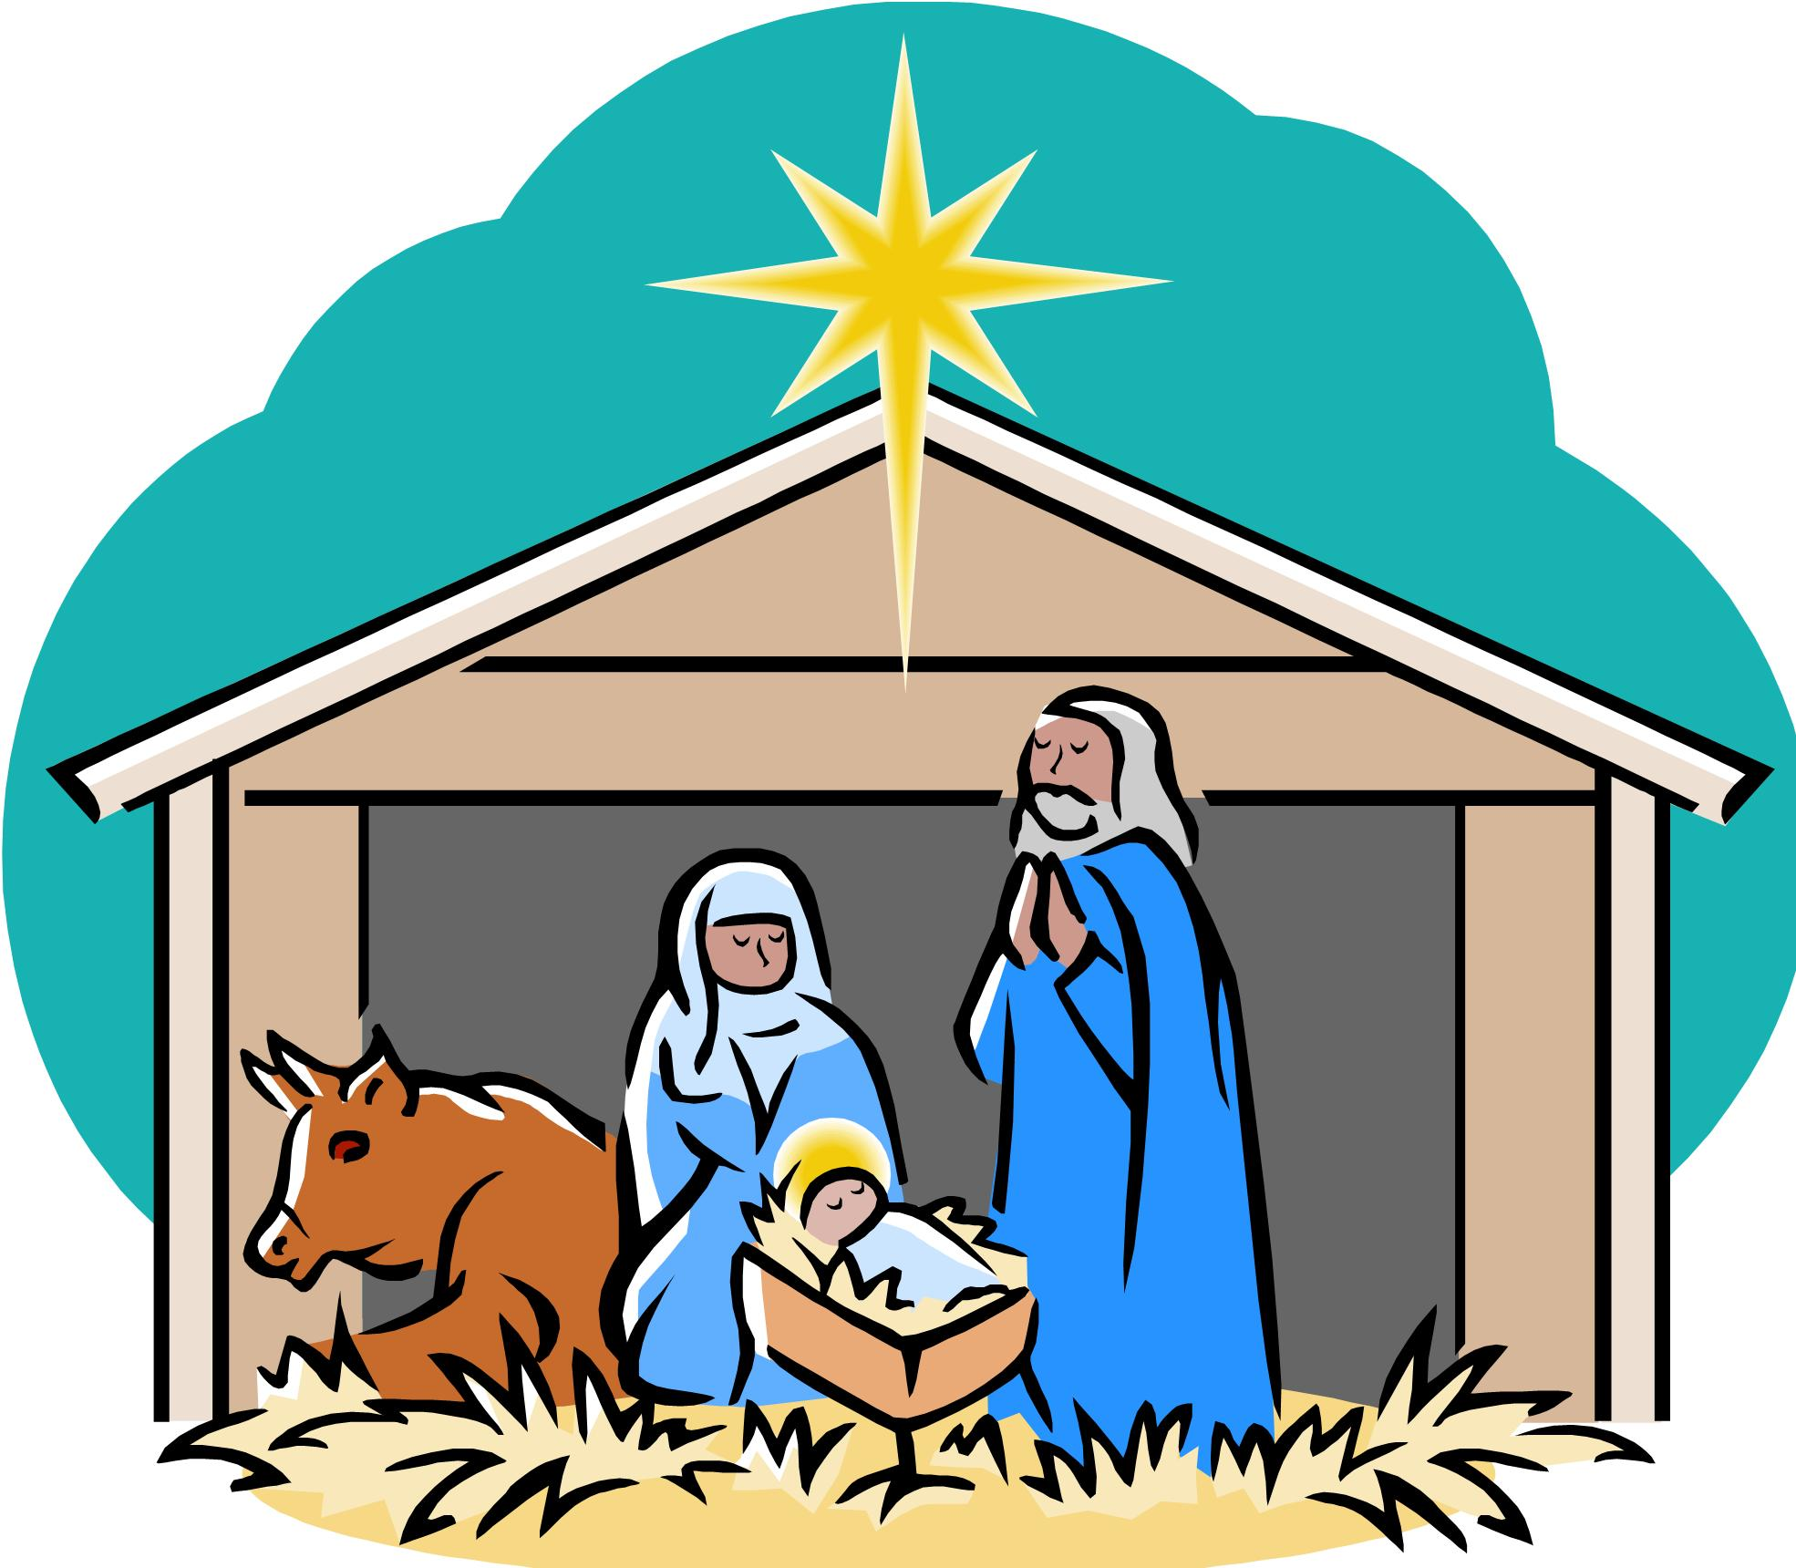
The Nativity
Making Xmas Cards
Addresses on Christmas envelopes and writing on Christmas cards
(Children becoming aware of surnames)
Craft – Xmas Crafts
Singing for the Season

Autumn & Winter
Weekly Guide
November – December 2024

W/C Monday 9th December 2024 Letter Sound Mm
Christmas Activities
Songs and Stories
Craft – Xmas Crafts
Krazy Kangas – Tuesday 10th 10.45am
Singing for the Season

W/C Monday 16th December 2024 Letter Sound Nn
Finish off all Christmas Creations
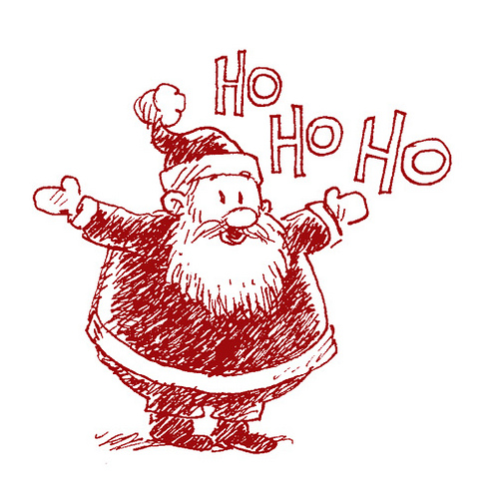
Xmas Performance will be Wednesday 18th December 4.30-5.30 Information will be given out nearer the time.
Craft – Finish off and hand out Xmas Crafts
Singing for the Season
Christmas Party is on Thursday 19th December
1pm – 3pm (No Sessions just the party)

OUR LAST SESSIONS ARE ON
WEDNESDAY 18th DECEMBER 2024
WE ARE BACK ON THURSDAY JANUARY 6th 2025

