Around the World in 55 Days
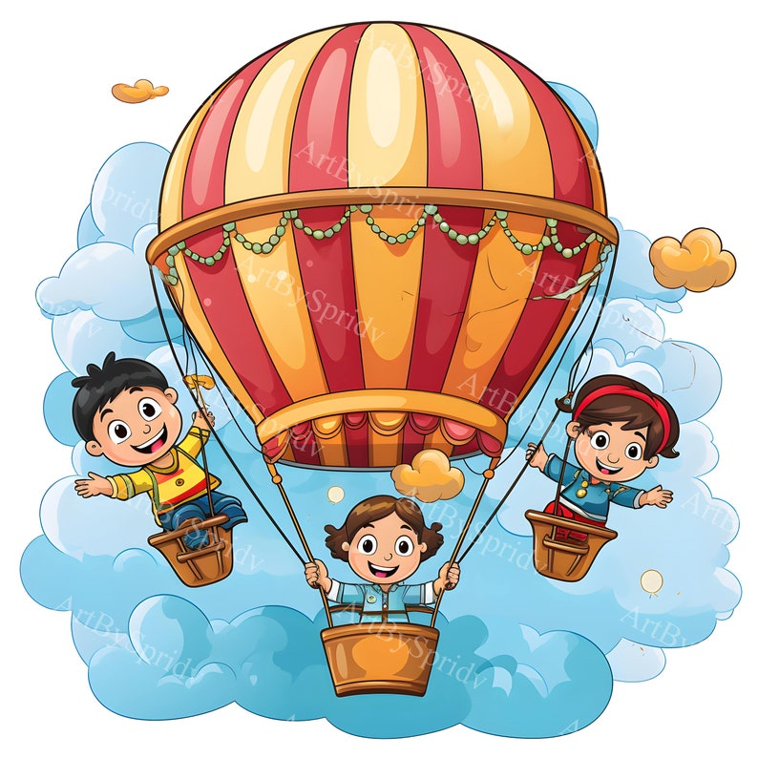

This Guide as you will see looks packed with things that we are hoping to chat about and look at, however, it is a guide and we will definitely not cover everything, but it gives staff lots of opportunities to teach them new words and find out lots about the different countries some of our children’s families come from. You are all very welcome to come in with pictures and things to show from your homelands, it will all add to the fun experiences the children will have.

W/C 6TH January 2025 Letter Sound Aa

Re-cap on Christmas Festivities
Looking at Different Weather
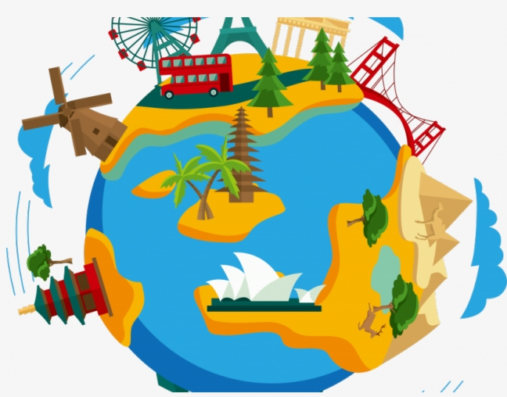
Settling back, Golden Rules and Feelings

Up Up Up in our Balloon – song book

Introduction to travelling around to different places in our world.

CT – Making Calendars (adding in Birthdays)

W/C 13th January 2025 Letter Sound Bb

The British Isles – England, Scotland, Wales, Ireland
Our Capital – London - Looking at London using books, postcards and artifacts
Swindon – Familiar Places that the children might recognise
CT - Free Painting

W/C 20th January 2025 Letter Sound Cc

Travelling to Europe Krazy Kangas Mon am

Linking in to where the children might have been on holidays.
France – Paris, Eiffel Tower, Arc de Triumph, Spain, Germany and Poland
How do we get there? Looking at different transport
Learning a new Language – Hello and Good Morning
CT - Sensory Activities

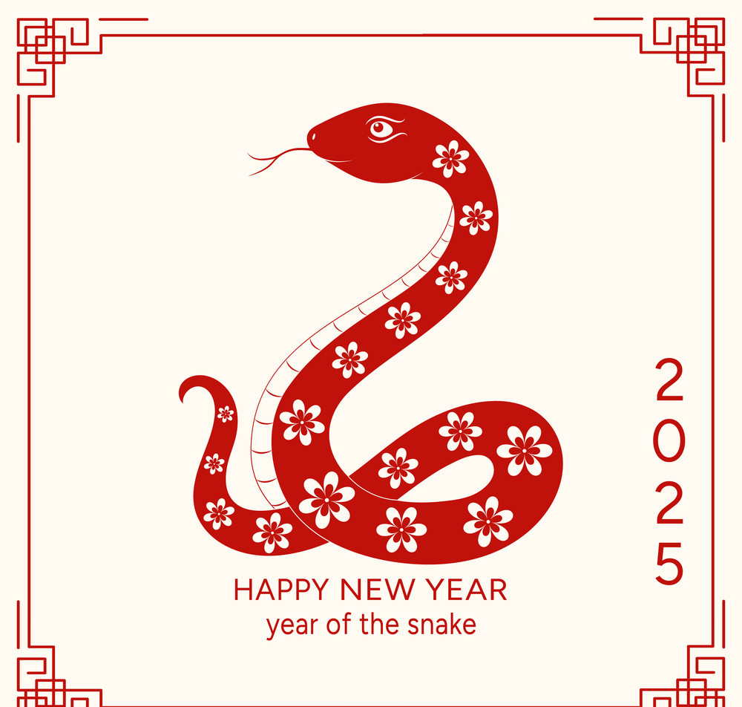
W/C 27th January 2025 Letter Sound Dd
China – The New Year (Wed 29th) year of the snake
Looking at Chinese images – The Panda – Temples – Dragons
Lanterns – Fans – The Great Wall – Chinese Writing (group activities)
Building the Great Wall of China with different construction toys
Eating Noodles using chop sticks – carrot, cucumber and Prawn Crackers

CT – Making Dancing Dragons, Lanterns and Pandas

W/C 3rd February 2025 Letter Sound Ee
Where the Snow Stays the Artic (north) –Antarctica (south)
Looking at the habitats and the animals that live there
Inuit’s and Igloos – ice and snow activities
CT - Snow/Ice Pictures - Penguins

W/C 10th February 2025 Letter Sound Ff
Revisit some of the things we have learnt about Krazy Kangas Tues pm
F is for flag – looking and colouring the different flags of the places we
have learnt about – Creating our own flag
Getting ready for the next part of our trip, maybe on a
Magic Carpet this time, when we will be going to Australia India and Africa ☺
Valentines all about Love and Hearts
CT – All about love and hearts

Half Term
Back on Monday 24th February


Around the World in 55 Days

W/C 24th February 2025 Letter Sound Gg
Australia – Animals, Snakes and Spiders
Kookaburra song
The Barrier Reef - Looking at all the beautiful fish and of course sharks!
Boomerangs and Didgeridoos
CT- Aborigine Art pictures using fingers and dots
West Swindon Library Trip on the Bus TBC

W/C 3rd March 2025 Letter Sound Hh
World Book Day Thursday 6th March Krazy Kangas Thur am
Various Stories from around the world
Children can dress up all week as their favourite characters
CT – Various Crafts that might represent books and stories

W/C 10th March 2025 Letter Sound Ii
Hindu Festival of Colours -Fri 14th (India – Nepal and South Asia)
The arrival of spring – Happy Holi
The Colourful Sandwich – The Children will make their own sandwiches adding different coloured foods (butter, cheese, tomatoes, lettuce, jam, cucumber, and marmite)
CT - Colour blowing and mixing

W/C 17th March 2025 Letter Sound Jj
India – Tigers and Elephants

Visual Aids using pictures and books – If it can be arranged, Indian dancing
The Taj Mahal – Golden Temple – The Ganges River
The Weather – Hot and Dry - The Monsoon
Traditional Dress – Sari’s
CT - Tiger Masks - Making Instruments – Drums, Shakers and Rainmakers
Begin Mother’s Day Craft

W/C 24th March 2025 Letter Sound Kk
Africa - Animals
Costumes and Homes
Books - Handa’s surprise (Fruit tasting from the story) & Mama Panya’s Pancakes
Hoping for someone to come in to do African Drumming

Northern Africa
The Hottest parts of the world
The Desert and its animals – Sahara – Egypt-Pyramids and the longest river in Africa, the Nile – Camels – Alice the camel has five humps!
CT – Junk Animals - Finish off Mother’s Day Craft

W/C 31st March 2025 Letter Sound Ll
The Himalayas – Krazy Kangas Thur pm
The mountain range that spans five countries India, Nepal, Bhutan, China (Tibet) and Pakistan -
Pakistan – Visitor in to look at items that are used to celebrate Eid al-Fitr
(Prayer, Food, Clothes, Gifts, Greetings and Decorations)
CT –Making a Mobile to hang up for Eid
Free Crafts

We will be having our Easter Egg Hunt after we come back from the Easter Break.
The Decorate an Egg Picture will be ready to give out during this last week. This is a fundraising event so please get one to do over the holidays. Thank you ☺

Happy Easter Break
We return on Tuesday 22nd

