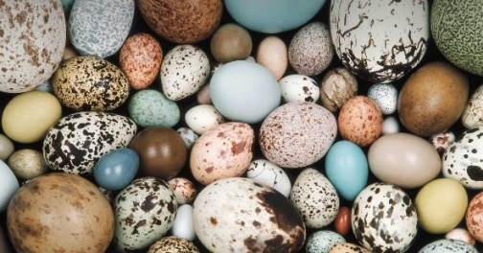

EGGS

WEEKLY GUIDE

APRIL – MAY 2025

W/C 22nd April 2025 (4 days) Letter Sound Mm

The Easter Egg Hunt – group challenge to see how many colourful eggs the children can find in the woodland walk.

Finding the giant egg – (another lovely way to extend imagination and language)

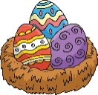Humpty Dumpty – Feelings - Changing the words to the rhyme to sit Humpty on different things.

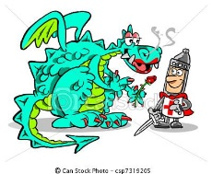The Judging of the Decorated Egg Pictures

St. Georges Day 23rd – Flag making (St. George and the Dragon)

**TADPOLES –** Life cycles(if we have not missed them)

W/C 28th April 2025 Mon: Krazy Kangas 2pm Letter Sound Nn

Looking at eggs – what lays them, the shapes and colours etc.

Looking on the computer and in books to find out facts and stories

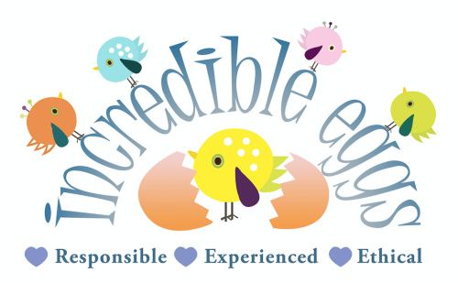Egg Carriers – Thinking about how we can construct something to protect the Eggs to keep them safe – Junk Models

The exciting arrival of our unhatched chicks

Finding out what we have to do to help them hatch safely and

then how to look after them, what they will need to grow,

being gentle and kind.

CT - Creating chick pictures, with feathers, tissue, wool etc

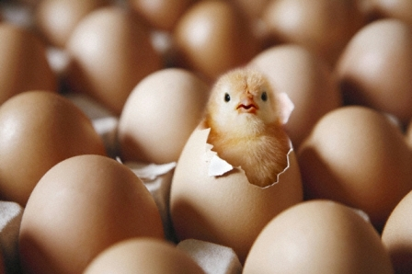W/C 6th May 2025 (4 days) Tues: Krazy Kangas 2pm Letter Sound Oo

Extend from last week with lots of opportunites to hold

and stroke the chicks

Take Chicks to Andrea on Thursday 8th when we have our

annual Lower Shaw Farm visits (am & pm) (Non Session Children list on bench)

Introduction to what we might find on a farm

Learning new words Arable - Crop - Wheat, Barley, Oats, Corn, Hay and Straw

Oats Beans and Barley Grow - Scarecrow Song - Farm Cat

Rows, Lines and Patterns

CT – Continue with chick pictures, with feathers, tissue, wool etc.

MC900383272[1]

HOW THINGS GROW

WEEKLY GUIDE

MAY 2025

W/C 12th May 2025 Letter Sound Pp

P is for Planting – what we need to make things grow.

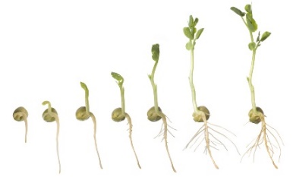Sequencing (sizing – growth) Watching the Bean shoot/grow on the window sill

The children to decorate their pot and plant their own Sunflower seeds

Extended Learning – Looking at information books of how things

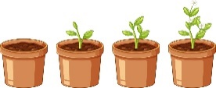grow and change

CT – Decorating Pots and Planting – Planting in the Jellytots Garden

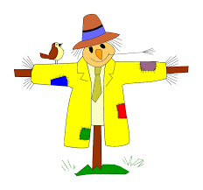 Scarecrows

W/C 19th May 2025 Letter Sound Qq

What crops are made into (Wheat, Barley, Oats and Corn)

Linking into breakfast - The breakfast song - Healthy Eating

Looking at different foods, playing food games – cheerio threading

MC900441866[1]MC900237221[1]CT – Drawing fruit (real fruit to look at/ examine and taste)

Sunflower Pictures - Scarecrows

Happy Half Term

We are back on 2ndJune

